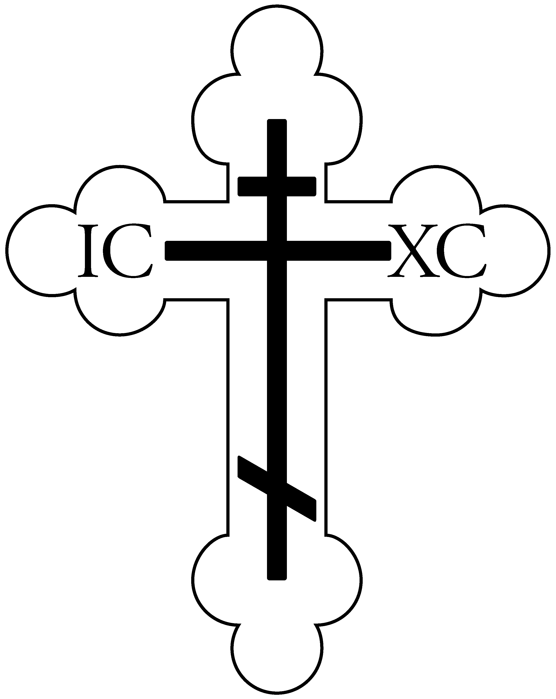

St. Vladimir Orthodox Church
812 Grand Street, Trenton, NJ 08610
(609) 393-1234 website: http://saintvladimir.org/

Sunday of Cheesefare: Explusion of Adam from Paradise
March 10, 2019
Troparion – Tone 8
Thou didst descend from on high, O Merciful One! Thou didst accept the three day burial to free us from our sufferings!// O Lord, our Life and Resurrection, glory to Thee!
Kontakion – Tone 8
By rising from the tomb, Thou didst raise the dead and resurrected Adam. Eve exults in Thy Resurrection, and the world celebrates Thy rising from the dead, O greatly Merciful One!
Kontakion – Tone 6
O Master, Teacher of wisdom, Bestower of virtue, Who teachest the thoughtless and protectest the poor, strengthen and enlighten my heart! O Word of the Father, let me not restrain my mouth from crying to Thee: Have mercy on me, a transgressor,// O merciful Lord!
Prokeimenon – Tone 8
Pray and make your vows before the Lord, our God!
v: In Judah God is known; His name is great in Israel.
Sunday of Cheesefare: Expulsion of Adam from Paradise
As we begin the Great Fast, the Church reminds us of Adam’s expulsion from Paradise. God commanded Adam to fast (Gen. 2:16), but he did not obey. Because of their disobedience, Adam and Eve were cast out of Eden and lost the life of blessedness, knowledge of God, and communion with Him, for which they were created. Both they and their descendents became heirs of death and corruption.
Let us consider the benefits of fasting, the consequences of disobedience, and recall our fallen state. Today we are invited to cleanse ourselves of evil through fasting and obedience to God. Our fasting should not be a negative thing, a mere abstention from certain foods. It is an opportunity to free ourselves from the sinful desires and urges of our fallen nature, and to nourish our souls with prayer, repentance, to participate in church services, and partake of the life-giving Mysteries of Christ.
At Forgiveness Vespers we sing: “Let us begin the time of fasting in light, preparing ourselves for spiritual efforts. Let us purify our soul, let us purify our body. As we abstain from food, let us abstain from all passion and enjoy the virtues of the spirit....”
Epistle: Romans 13:11-14:4
And do this, knowing the time, that now it is high time to awake out of sleep; for now our salvation is nearer than when we first believed. The night is far spent, the day is at hand. Therefore let us cast off the works of darkness, and let us put on the armor of light. Let us walk properly, as in the day, not in revelry and drunkenness, not in lewdness and lust, not in strife and envy. But put on the Lord Jesus Christ, and make no provision for the flesh, to fulfill its lusts. Receive one who is weak in the faith, but not to disputes over doubtful things. For one believes he may eat all things, but he who is weak eats only vegetables. Let not him who eats despise him who does not eat, and let not him who does not eat judge him who eats; for God has received him. Who are you to judge another’s servant? To his own master he stands or falls. Indeed, he will be made to stand, for God is able to make him stand.
Gospel: Matthew 6:14-21
For if you forgive men their trespasses, your heavenly Father will also forgive you. But if you do not forgive men their trespasses, neither will your Father forgive your trespasses. Moreover, when you fast, do not be like the hypocrites, with a sad countenance. For they disfigure their faces that they may appear to men to be fasting. Assuredly, I say to you, they have their reward. But you, when you fast, anoint your head and wash your face, so that you do not appear to men to be fasting, but to your Father who is in the secret place; and your Father who sees in secret will reward you openly. Do not lay up for yourselves treasures on earth, where moth and rust destroy and where thieves break in and steal; but lay up for yourselves treasures in heaven, where neither moth nor rust destroys and where thieves do not break in and steal. For where your treasure is, there your heart will be also.
Service Schedule for the week of March 10
Today – 9:00 AM Sunday School, 9:45 AM Hours, 10:00 AM Divine Liturgy followed by Ceremony of Mutual Forgiveness; then
Coffee Hour in Daria Hall
Monday March 11 – 7:00 PM, Great Canon of St. Andrew of Crete (Trenton)
Tuesday March 12 – 7:00 PM, Great Canon of St. Andrew of Crete (St. Spiridon Church in Perth Amboy)
Wednesday March 13 – 6:00 PM, Great Canon of St. Andrew of Crete (Princeton Chapel)
Friday March 15 – 8:30 AM Confession, 9:30 AM Pre-Sanctified Liturgy followed by Confession
Saturday March 16 – 5:00 PM Vespers followed by Confession
Sunday March 17 – 9:00 AM Sunday School, 9:45 AM Hours, 10:00 Divine Liturgy followed by Coffee Hour in Daria Hall
Weekly Giving
March 3 – 43 adults, 11 youth, $1,588
Parish Announcements
The Parish Council Meeting will be held on Thursday March 14 at 7:00 PM.
Starting in March and continuing through Pascha, Bible Study classes will be held on the 1st and 3rd Tuesdays of each month at 7:00 PM in the church basement. The next classes will be held on Tuesday March 19 and Tuesday April 2. All are welcome to attend.
The Senior R Club is selling Gertrude Hawks chocolate Easter candy again this year. Please see Paul or Betty Kavchok for a catalog or to turn in your completed order form on or before March 24.

Daria Hall kitchen clean-up day is scheduled for Saturday March 23 at 11:00 AM after Memorial Saturday Divine Liturgy. If you are available, please stop by to help. We need to clear out the coatroom as well to make room for dinnerware that will be boxed up from the kitchen so that food items can be stored in the cabinets vs. on top of the counters.

The Ladies Altar Society is a Ministry dedicated to supporting charities and the growth of St. Vladimir Church. The group meets several times during the year and holds fundraisers periodically. To become a member of this worthwhile group, please see Nadja Nowicki or Father Volodymyr.

