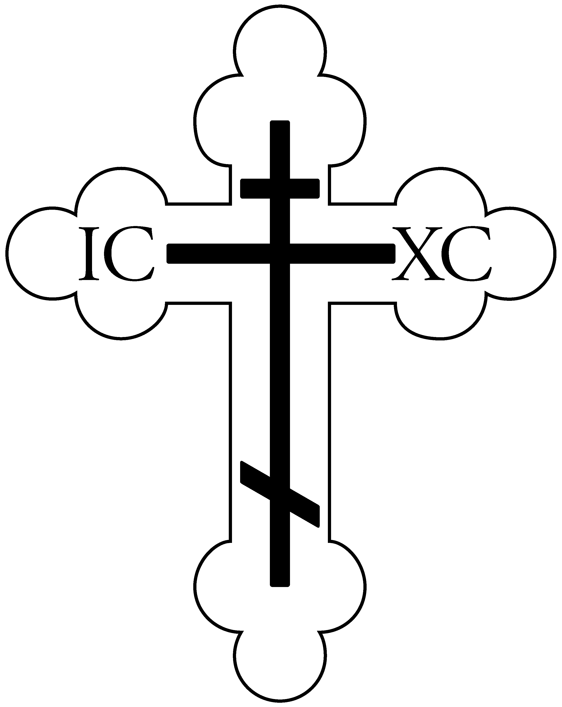

St. Vladimir Orthodox Church
812 Grand Street, Trenton, NJ 08610
(609) 393-1234 website: http://saintvladimir.org/
FACEBOOK PAGE:
https://www.facebook.com/St-Vladimir-Orthodox-Church-Trenton-NJ-454092552035666

Afterfeast of the Elevation of the Cross /
Greatmartyr Nicetas the Goth
September 15, 2019
Troparion – Tone 4
When the women disciples of the Lord learned from the angel the joyous message of thy Resurrection, they cast away the ancestral curse and elatedly told the apostles: “Death is overthrown! Christ God is risen,// granting the world great mercy!”

Troparion – Tone 1
O Lord, save Thy people and bless Thine inheritance! Grant victories to the Orthodox Christians over their adversaries; and by virtue of Thy Cross,// preserve Thy habitation!
Troparion – Tone 3
Thou didst defeat error and didst triumph in martyrdom, Nicetas, namesake of victory; for thou didst conquer the ranks of the enemy and ended thy ↑contest by fire.// Pray to Christ our God to grant us His great mercy!
Kontakion – Tone 4
My Savior and Redeemer as God rose from the tomb and delivered the earth-born from their chains. He has shattered the gates of hell, and as Master,// He has risen on the third day!
Kontakion – Tone 2
Thou didst stand firm and didst defeat delusion and hast received thy martyr’s crown, Nicetas, namesake of victory; thou art rejoicing with the Angels, together with them thou art praying unceasingly to Christ God for us all.
Kontakion – Tone 4
As Thou wast voluntarily raised upon the Cross for our sake, grant mercy to those who are called by Thy Name, O Christ God; make all Orthodox Christians glad by thy pow’r, granting them victories over their adversaries// by bestowing on them the invincible trophy, Thy weapon of peace!

Prokeimenon – Tone 7
Extol the Lord our God: worship at His footstool for He is holy!
v: The Lord reigns, let the people tremble!

Afterfeast of the Elevation of the Cross
From September 15 until the Leavetaking, we sing “O come, let us worship and fall down before Christ. O son of God crucified in the flesh, save us who sing to Thee: Alleluia” at weekday Liturgies following the Little Entrance.
Greatmartyr Nicetas the Goth
The Holy Great Martyr Nicetas was a Goth (a Germanic tribe). He was born and lived on the banks of the Danube River, and suffered for Christ in the year 372. The Christian Faith was then already widely spread throughout the territory of the Goths. Saint Nicetas believed in Christ and accepted Baptism from the Gothic bishop Theophilus, a participant in the First Ecumenical Council. Pagan Goths began to oppose the spread of Christianity, which resulted in internecine strife.
After the victory of Fritigern, heading a Christian army and inflicting defeat on the pagan Athanaric, the Christian Faith began to spread increasingly among the Goths. The Arian bishop Ulfilas, the successor to Bishop Theophilus, created a Gothic alphabet and translated into the Gothic language many priestly books. Saint Nicetas worked intensely among his fellow Goths at spreading Christianity. By his personal example and inspired words he brought many pagans to the Christian Faith.
However, after his defeat Athanaric again contrived to gather his own forces, return to his own country and regain his former power. Since he remained a pagan, he continued to hate Christians and persecute them.
Saint Nicetas endured many tortures, and died after being thrown into a fire. His body remained unharmed by the fire and was illumined by a miraculous light. By night, a friend of the martyr, a Christian named Marianus, retrieved the body of Saint Nicetas, and buried it in Cilicia. Afterwards, it was transferred to Constantinople. Part of the relics of the Great Martyr Nicetas were later transferred to the monastery of Vysokie Dechani in Serbia. Saint Nicetas received an unfading crown of glory from Christ in the year 372.
We pray to Saint Nicetas for the preservation of children from birth defects.
Epistle: Galatians 2:16-20
Knowing that a man is not justified by the works of the law but by faith in Jesus Christ, even we have believed in Christ Jesus, that we might be justified by faith in Christ and not by the works of the law; for by the works of the law no flesh shall be justified. But if, while we seek to be justified by Christ, we ourselves also are found sinners, is Christ therefore a minister of sin? Certainly not! For if I build again those things which I destroyed, I make myself a transgressor. For I through the law died to the law that I might live to God. I have been crucified with Christ; it is no longer I who live, but Christ lives in me; and the life which I now live in the flesh I live by faith in the Son of God, who loved me and gave Himself for me.
Epistle: 1 Corinthians 16:13-24
Watch, stand fast in the faith, be brave, be strong. Let all that you do be done with love. I urge you, brethren – you know the household of Stephanas, that it is the firstfruits of Achaia, and that they have devoted themselves to the ministry of the saints – that you also submit to such, and to everyone who works and labors with us. I am glad about the coming of Stephanas, Fortunatus, and Achaicus, for what was lacking on your part they supplied. For they refreshed my spirit and yours. Therefore acknowledge such men. The churches of Asia greet you. Aquila and Priscilla greet you heartily in the Lord, with the church that is in their house. All the brethren greet you. Greet one another with a holy kiss. The salutation with my own hand – Paul’s. If anyone does not love the Lord Jesus Christ, let him be accursed. O Lord, come! The grace of our Lord Jesus Christ be with you. My love be with you all in Christ Jesus. Amen.
Gospel: Mark 8:34-9:1
When He had called the people to Himself, with His disciples also, He said to them, “Whoever desires to come after Me, let him deny himself, and take up his cross, and follow Me. For whoever desires to save his life will lose it, but whoever loses his life for My sake and the gospel’s will save it. For what will it profit a man if he gains the whole world, and loses his own soul? Or what will a man give in exchange for his soul? For whoever is ashamed of Me and My words in this adulterous and sinful generation, of him the Son of Man also will be ashamed when He comes in the glory of His Father with the holy angels.” And He said to them, “Assuredly, I say to you that there are some standing here who will not taste death till they see the kingdom of God present with power.”
Gospel: Matthew 21:33-42
Hear another parable: There was a certain landowner who planted a vineyard and set a hedge around it, dug a winepress in it and built a tower. And he leased it to vinedressers and went into a far country. Now when vintage-time drew near, he sent his servants to the vinedressers, that they might receive its fruit. And the vinedressers took his servants, beat one, killed one, and stoned another. Again he sent other servants, more than the first, and they did likewise to them. Then last of all he sent his son to them, saying, ‘They will respect my son.’ But when the vinedressers saw the son, they said among themselves, ‘This is the heir. Come, let us kill him and seize his inheritance.’ So they took him and cast him out of the vineyard and killed him. Therefore, when the owner of the vineyard comes, what will he do to those vinedressers?” They said to Him, “He will destroy those wicked men miserably, and lease his vineyard to other vinedressers who will render to him the fruits in their seasons.” Jesus said to them, “Have you never read in the Scriptures: ‘The stone which the builders rejected Has become the chief cornerstone. This was the LORD’s doing, and it is marvelous in our eyes’?
Service Schedule for the week of September 15
Today – 9:45 AM Hours, 10:00 AM Divine Liturgy followed by Coffee Hour in Daria Hall
Saturday, September 21 – 5:00 PM Vespers followed by Confession
Sunday September 22 – 9:45 AM Hours, 10:00 AM Divine Liturgy. The annual church picnic will start approx.
12:30 PM at the church picnic grounds on Rt. 33 in Hamilton.
Weekly Giving
September 8 – 41 adults, 12 youth, $1,317
Parish Announcements
Volunteers to host Coffee Hour are needed! It can be as simple as donuts, bagels, and coffee. Please see Melody Stavisky or Michael Toth. Thank you!
Bible Study classes are the 2nd and 4th Wednesdays of each month at 7:00 PM. The next two will be on September 25 and October 9.
On Saturday October 19 the Sunday School children will travel to St. Tikhon’s Seminary for a day visit. Any adults interested in attending please see Father Volodymyr or Melody Stavisky. We will need parental chaperones as well.
All hands on deck – Nadja Nowicki is organizing a pierogi making session for Friday Oct. 4 and Saturday Oct. 5 as a church fundraiser; times will be announced at a later date. Many hands are needed to roll, pinch, cook, and pack the pierogies. Nadja is accepting monetary donations so she can purchase the ingredients. Thank you in advance for your help and support!

