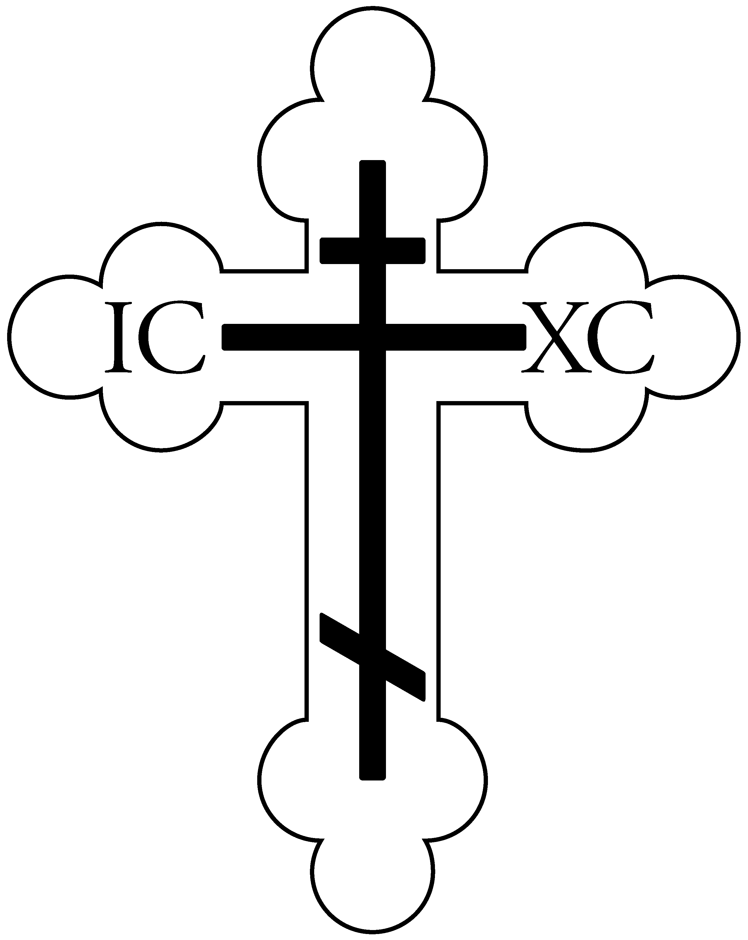

St. Vladimir Orthodox Church
812 Grand Street, Trenton, NJ 08610 (609) 393-1234
Rev. Volodymyr Chaikivskyi V. Rev. Paul Shafran, Pastor Emeritus
Website: saintvladimir.org
Facebook: facebook.com/St-Vladimir-Orthodox-Church-Trenton-NJ-454092552035666
SUNDAY OF THE PARALYTIC
May 7, 2023

Christ Is Risen! Indeed He Is Risen!
TROPARION, KONTAKION & PROKEIMENON
Troparion – Tone 3
Let the heavens rejoice! Let the earth be glad! For the Lord has shown strength with His arm. He has trampled down death by death. He has become the first born of the dead. He has delivered us from the depths of hell, and has granted to the world// great mercy.
Troparion – Tone 4
O righteous Father Alexis, our heavenly intercessor and teacher, divine adornment of the Church of Christ, entreat the Master of All to strengthen the Orthodox Faith in America, to grant peace to the world// and to our souls great mercy!
Kontakion – Tone 5
Let us, the faithful, praise the Priest Alexis, a bright beacon of Orthodoxy in America, a model of patience and humility, a worthy shepherd of the flock of Christ! He called back sheep who had been led astray and brought them by his preaching// to the Heavenly Kingdom.
Kontakion – Tone 3
By Your divine intercession, O Lord, as You raised up the Paralytic of old, so raise up my soul, paralyzed by sins and thoughtless acts; so that being saved I may sing to You:// “Glory to Your power, O compassionate Christ!”
Prokeimenon – Tone 1
Let Your mercy, O Lord, be upon us /as we have set our hope on Thee!
V. Rejoice in the Lord, O you righteous! Praise befits the just!
Prokeimenon – Tone 7
The righteous shall rejoice in the Lord / and shall hope in Him.
LITURGICAL COMMEMORATION
Sunday of the Paralytic
Many miracles in the Old Testament involve water. To name but a few, the water of the Nile turned to blood after Moses lifted his rod and struck the water before Pharaoh and His servants (Exodus 7:20). Not only was the Nile turned to blood, but also "their rivers, their canals, their ponds, and all their pools of water, that they may become blood; and there shall be blood throughout the land of Egypt, both in vessels of wood and in vessels of stone" (Exodus 7:19).
In chapter 14 of Exodus, Moses divided the waters of the Red Sea, and the Hebrews passed over as if on dry land. When they were safely across, the waters came together, and their Egyptian pursuers were drowned. On their forty year journey to the Promised Land, the Hebrews camped at Rephidem, but there was no water for them to drink. The people
murmured against Moses, asking him why he had led them out of Egypt. God told Moses to strike the rock at Horeb. Then water came out of it so that everyone could drink (Exodus 17:6). In Judges 6:36-40 we read about Gideon and the dew on the fleece. When Gideon squeezed the fleece, there was enough to fill a bowl with water.
On the Fourth Sunday of Pascha, the Church remembers the man who lay paralyzed at the Sheep Pool in Jerusalem for thirty-eight years, waiting for someone to put him into the pool. The first person to enter the pool after an Angel troubled the water would be healed of his infirmities, but someone always entered the pool before him. Seeing the man, the Lord felt compassion for him and healed him. The Lord healed the paralytic during the days of the Passover, when He had gone to Jerusalem for the Feast, and He remained there teaching and working miracles. According to Saint John the Theologian, this miracle took place on the Sabbath.
Like some Old Testament miracles, many of Christ's miracles also involved water, and they prefigure the Church's Baptism, which cleanses us of every sin. In the Sheep Pool, once a year, only one person was healed, but Christ saves endless multitudes by divine Baptism. Sometimes, as in the case of Saint Vladimir (July 15), Baptism can also heal our bodily infirmities.
In the Canon for the Paralytic, the Angel who stirred the water in the Sheep Pool is identified as the Archangel Michael. Some of the Troparia call him "Leader of the Angels," and "Supreme Commander" (Ode 1). In Ode 3 we ask him to "protect us from falling into the passions of life." In Ode 6, we ask Saint Michael to guide us on the paths of life." In Ode 8, we ask him to pray with all the Bodiless Hosts, that we may be granted deliverance from our offenses, correction of our life, and the enjoyment of eternal blessings. As we remember the paralytic, let us ask Christ to "raise up our souls, paralyzed by sins and thoughtless acts" (Kontakion of the paralytic).
EPISTLE & GOSPEL READINGS
Epistle: Acts 9:32-42
Now it came to pass, as Peter went through all parts of the country, that he also came down to the saints who dwelt in Lydda. There he found a certain man named Aeneas, who had been bedridden eight years and was paralyzed. And Peter said to him, “Aeneas, Jesus the Christ heals you. Arise and make your bed.” Then he arose immediately. So all who dwelt at Lydda and Sharon saw him and turned to the Lord. At Joppa there was a certain disciple named Tabitha, which is translated Dorcas. This woman was full of good works and charitable deeds which she did. But it happened in those days that she became sick and died. When they had washed her, they laid her in an upper room. And since Lydda was near Joppa, and the disciples had heard that Peter was there, they sent two men to him, imploring him not to delay in coming to them. Then Peter arose and went with them. When he had come, they brought him to the upper room. And all the widows stood by him weeping, showing the tunics and garments which Dorcas had made while she was with them. But Peter put them all out, and knelt down and prayed. And turning to the body he said, “Tabitha, arise.” And she opened her eyes, and when she saw Peter she sat up. Then he gave her his hand and lifted her up; and when he had called the saints and widows, he presented her alive. And it became known throughout all Joppa, and many believed on the Lord.
Epistle: Galatians 1:11-19
But I make known to you, brethren, that the gospel which was preached by me is not according to man. For I neither received it from man, nor was I taught it, but it came through the revelation of Jesus Christ. For you have heard of my former conduct in Judaism, how I persecuted the church of God beyond measure and tried to destroy it. And I advanced in Judaism beyond many of my contemporaries in my own nation, being more exceedingly zealous for the traditions of my fathers. But when it pleased God, who separated me from my mother’s womb and called me through His grace, to reveal His Son in me, that I might preach Him among the Gentiles, I did not immediately confer with flesh and blood, nor did I go up to Jerusalem to those who were apostles before me; but I went to Arabia, and returned again to Damascus. Then after three years I went up to Jerusalem to see Peter, and remained with him fifteen days. But I saw none of the other apostles except James, the Lord’s brother.
Gospel: John 5:1-15
After this there was a feast of the Jews, and Jesus went up to Jerusalem. Now there is in Jerusalem by the Sheep Gate a pool, which is called in Hebrew, Bethesda, having five porches. In these lay a great multitude of sick people, blind, lame, paralyzed, waiting for the moving of the water. For an angel went down at a certain time into the pool and stirred up the water; then whoever stepped in first, after the stirring of the water, was made well of whatever disease he had. Now a certain man was there who had an infirmity thirty-eight years. When Jesus saw him lying there, and knew that he already had been in that condition a long time, He said to him, “Do you want to be made well?” The sick man answered Him, “Sir,
I have no man to put me into the pool when the water is stirred up; but while I am coming, another steps down before me.” Jesus said to him, “Rise, take up your bed and walk.” And immediately the man was made well, took up his bed, and walked. And that day was the Sabbath. The Jews therefore said to him who was cured, “It is the Sabbath; it is not lawful for you to carry your bed.” He answered them, “He who made me well said to me, ‘Take up your bed and walk.’” Then they asked him, “Who is the Man who said to you, ‘Take up your bed and walk’?” But the one who was healed did not know who it was, for Jesus had withdrawn, a multitude being in that place. Afterward Jesus found him in the temple, and said to him, “See, you have been made well. Sin no more, lest a worse thing come upon you.” The man departed and told the Jews that it was Jesus who had made him well.
Gospel: John 10:1-9
So it was, as the multitude pressed about Him to hear the word of God, that He stood by the Lake of Gennesaret, and saw two boats standing by the lake; but the fishermen had gone from them and were washing their nets. Then He got into one of the boats, which was Simon’s, and asked him to put out a little from the land. And He sat down and taught the multitudes from the boat. When He had stopped speaking, He said to Simon, “Launch out into the deep and let down your nets for a catch.” But Simon answered and said to Him, “Master, we have toiled all night and caught nothing; nevertheless at Your word I will let down the net.” And when they had done this, they caught a great number of fish, and their net was breaking. So they signaled to their partners in the other boat to come and help them. And they came and filled both the boats, so that they began to sink. When Simon Peter saw it, he fell down at Jesus’ knees, saying, “Depart from me, for I am a sinful man, O Lord!” For he and all who were with him were astonished at the catch of fish which they had taken; and so also were James and John, the sons of Zebedee, who were partners with Simon. And Jesus said to
Simon, “Do not be afraid. From now on you will catch men.” So when they had brought their boats to land, they forsook all and followed Him.
SERVICES
Service Schedule for the week of May 7
Sunday May 7 – 9:45 AM Hours, 10:00 AM Divine Liturgy followed by Coffee Hour in Daria Hall
Saturday May 13 – 5:00 PM Vespers followed by Confession
Sunday May 14 – 9:45 AM Hours, 10:00 AM Divine Liturgy followed by Coffee Hour in Daria Hall
DONATIONS
Weekly Giving
April 30 – 78 adults, 19 youth, $2,281

PARISH ANNOUNCEMENTS
As a reminder, St. Vladimir’s offers an online giving program to contribute to the support of the parish. One of the biggest benefits of online giving is the ability to set up scheduled recurring donations. This allows you to be faithful and consistent in your generosity, even when you are unable to attend church services, and allows us to plan and budget consistently as a church. If you need assistance in setting up an online giving account, please see a member of the Parish Council. Thank you.

This coming Saturday May 13 at 9:30 AM, brush and debris at the church picnic grounds will be cleaned. Please plan on helping.
The Ladies Altar Society is raffling a Mother's Day Basket. Raffle tickets are $1.00 each and will be sold during Coffee Hour today and next Sunday, May 14. The winner will be picked on May 14 as well. Thank you for your support!
In our country's continuing attempt to reduce our carbon footprint and to preserve God's world, recycling refuse is an ongoing issue. We have tried using a yellow trash receptacle in Daria Hall, but it is largely misused. Therefore, a new red recycling covered bin is in Daria Hall. Items to be recycled HAVE NOT CHANGED, and include plastic bottles, plastic jugs, glass jars and bottles, cardboard and boxes, and plastic containers labeled 1 and 2. No plastic bags, food encrusted items of any sort, food, coffee cups, napkins, or plastic utensils are to be disposed of in this bin. PLEASE be considerate and choose the appropriate bin in which to dispose of your trash. Thank you for helping us to care for God's world!

Our parish will host a Summer Camp for parish children the week of June 26. Hours will be 9:00 AM to 3:00 PM. More details and a sign-up sheet will be available in a few weeks.

A Parish "Directory" with photos and identifying names of all parishioners is in the works. This will help us all with "putting a face to the name"! When you are at Daria Hall for Coffee Hour, please see Awet Tesfa to get your picture taken.

The Ladies Altar Society is creating and publishing the first Parish Cookbook – with your help! We are interested in your favorite recipes, ethnic recipes, recipes from your grandparents, parents, children, relatives and friends, and Lenten recipes. They can include Appetizers, Main Meals, Side Dishes, Soup, Salad, Dessert, and Beverages. In addition to recipes, the Cookbook will include a Helpful Hints section. In order for the Cookbook to be a success, we will need many recipes! Each recipe should include your name, who you may have received the recipe from, and your phone number (phone number is only if we have questions and will not be published in the Cookbook). Please give your recipes to Alla Strauss, Melody Stavisky, or Nancy Mitsos. Thank you!

BIRTHDAYS THIS WEEK

Dcn. Bohdan Chaikivskyi – May 9

Anne Cheslock – May 11

Have a blessed birthday and may God grant you many years!

If you do not see your birthday listed above during your birthday week, please let Darice know and she will add it to the schedule!

COFFEE HOUR SCHEDULE
Please remember the Coffee Hour Helpers do not normally bring any refreshments for Coffee Hour, but are there to assist in setting up for Coffee Hour. The host/hostess is responsible for bringing whatever refreshments they wish to serve – if desserts are needed please let the Helper know ahead of time as there are desserts in the freezer that may be used. Host/Hostess is responsible for setting up in the morning starting at 9:00 AM, with guidance from the Helper, and for cleaning up after Coffee Hour including washing and drying dishes, and taking out the trash. If you have any questions please contact Melody Stavisky, Alla Strauss, or the Helper assigned to your Coffee Hour date. Thank you!

May 7 Fiyori Habtesilasse, Awet Tesfa
May 14 Nina Schmidt, Alla Strauss
May 21 Aftan Chowansky, Nina Laushell
May 28 Christina DiDonato, Francine Brady, Herman Meyer
June 4 Darice Keyes, Nancy Mitsos
June 11 Bill & Margie DiCicco, Chris Kasmer, Nina Laushell, FOCA Club
June 18 FAST Timothy & Valeria Srock, Awet Tesfa
June 25 FAST Alla & Perry Strauss, Christine Waite
July 2 Alex & Brittani Brasowski, Melody Stavisky
July 9 Jessica & Blake Kilgore, Darice Keyes
July 16 ST. VLADIMIR FEAST DAY BANQUET
July 23 Karina Kotelnicki, Nina Laushell
July 30 Tyler Burger, Francine Brady, Herman Meyer
Aug. 6 FAST Mihaela & Tiberiu Milosav, Alla Strauss
Aug. 13 FAST Herman Meyer, Francine Brady
Aug. 20 Alex & Rebeca Medina, Awet Tesfa
Aug. 27 Olga & James Bates, Darice Keyes
Sept. 3 Tahara & Germain Ortiz, Alla Strauss
Sept. 10 Monia & James Pitra, Darice Keyes
Sept. 17 Gabriela & Virgiliu Plesa, Nina Laushell
Sept. 24 ANNUAL PARISH PICNIC
Oct. 1 Guy Radcliffe, Francine Brady, Herman Meyer
Oct. 8 John Cassar, Alla Strauss
Oct. 15 Lynne Sheedy, Nancy Mitsos
Oct. 22 Ramazi Shubitize, Awet Tesfa
Oct. 29 Nina Laushell, Darice Keyes
Nov. 5 Walter & Tanya Tribbey, Francine Brady, Herman Meyer
Nov. 12 Vera Pschenyczny, Alla Strauss
Nov. 19 FAST Nancy Mitsos, Darice Keyes
Nov. 26 FAST Gebrekvistos Amleset, Awet Tesfa
Dec. 3 FAST Ilonica & Corneliu Balasa, Nina Laushell
Dec. 10 FAST Victoria Baranava, Nancy Mitsos
Dec. 17 FAST Paula & Ludwig Koerte, Darice Keyes
Dec. 24 FAST Father Volodymyr & Matushka Oksana, Alla Strauss
Dec. 31 Paul & Patti Denko, Francine Brady, Herman Meyer
Jan. 7 '24 Alex Godun, Nina Laushell

